PROVIDENCE HOUSING AUTHORITY

RESIDENT SERVICES
BOARD OF COMMISSIONERS SUBCOMMITTEE MEETING
Major Projects Report-COVID 19
August 27, 2020

RESIDENT SERVICES DEPARTMENT

COVID 19 Updates:
The Resident Services Department staff returned to work on Tuesday, September 8th
The RSD’s approach to COVID 19 has been to serve Residents through an interdepartmental approach.
- Emergency Resident Outreach Log (EROL)-The EROL targeting all public housing residents started at the beginning of the crisis and has evolved with multiple phases.
PHASE 6 continuous improvement: The Office of Strategy and Development identified CallMax as the vendor/system to do mass callings to developments on a variety of issues including but not limited to; FM operations information, COVID testing, Food delivery, Providence Public School District (PPSD) deadline reminder for signing up for remote on-line learning, and voter registration reminders.
PHASE 7: Identify and outreach to potential partners to support food delivery and COVID testing.
PHASE 8: Program Outreach: (1) youth between the ages of 16-24 for WIOA Workforce program, and (2) Family developments for 20% participation in survey required for ROSS SC grant application
Additional Resident Outreach:
- PHA established its own COVID 19 Hotline- In August there were 65 Covid specific calls made that were tracked in the COVID 19 Hotline spreadsheet; Dexter Manor (7); Hartford Park Tower (3); Carroll Tower (10); Chad Brown (11); Kilmartin Plaza (4); Manton Heights (10); Dominica Manor (3); Codding Court (4); Sect 8 (5); Hartford Park (4); Parenti Villa (1); SS(3). Additionally, 83 calls were made to inform Residents of Covid neg. results at PV, and 84 calls for Covid neg results at CT
- Food Task Force and Delivery Service – Continues as an interdepartmental effort. Please see tables below for; (1) PHA food boxes, and (2) total number of boxes from PHA and RIFB delivered monthly
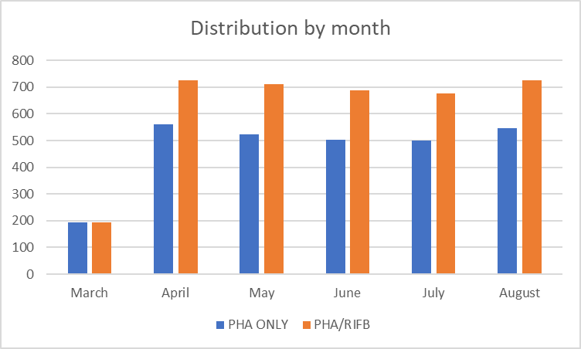

Other Food Programs:

Frozen meals from the City of Providence: PM staff picked up an additional 300 meals to distribute.
.
Family Service of RI: Be Safe Plus program delivers boxes of fresh and shelf stable food, and cleaning supplies to elderly Rhode Islanders. 60 Be Safe Plus meals have been delivered to PHA households at Manton Heights, Chad Brown, Hartford Park, Dexter Manor and Codding Court.

Program Updates:
- WELLNESS PROGRAMS:
Wellness Coordinator/SOR
- Current caseload of 20
- During weekly Coffee and Conversation zoom meetings, a Hartford Park resident identified participation in the group as a source of support for her in a difficult time in which she is dealing with the anniversary of the death of her son due to suicide and her own relapse concerning alcoholism. She related that since rejoining the group that she has developed stronger relationships with people in the group and that members call her during the weekend to check in with her.
- Coordinating with the Rhode Island Quality Institute (RIQI) data quality issues in the RIQI database KnowMyHealthRI system for the Government Performance and Results Act (GPRA) assessment for BHDDH

VOCA Coordinator
- Coordination for an additional 5 high risk active cases in August
- Continuous review of weekly Security Reports to offer remote services
- Has encouraged participation in on-line group meetings
- Development Virtual Self-Care workshop for VOCA clients to start in July

Staff and Program Up-dates for Wellness:
- A new Community Health Worker was hired and started on 9/8/2020
- A new Licensed Clinical Social worker was hired and started on 9/14/2020

- WORKFORCE PROGRAMS:
Jobs Plus Providence (JPP) Program
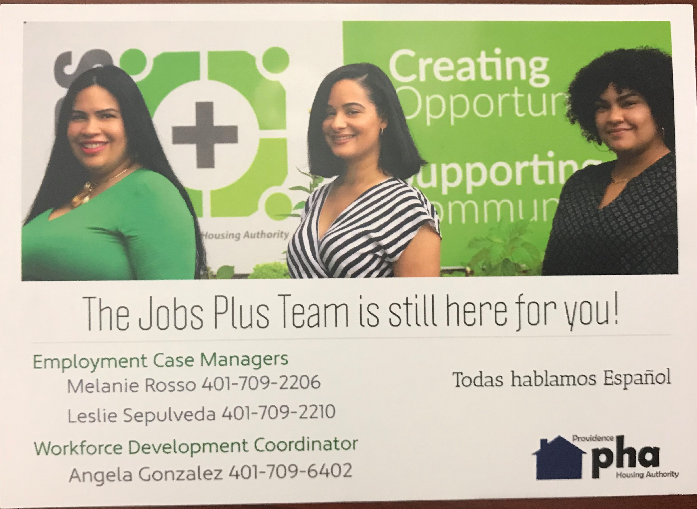
HUD Jobs Plus Program Close-out Activities:
- Community Outreach Workers continue their targeted outreach and asking the following questions: 1. Have you been laid off during the pandemic? (If yes, would you like to meet with our Employment Case Managers?) 2. During this time do you need resources? For example, food assistance or clothing? (If yes, can I share your information with an Employment Case Manager) 3. Do you have any other questions or concerns that I can try to help you with at this time? All the answers are tracked and the Employment Case Managers follow-up with the residents within 48 hours.
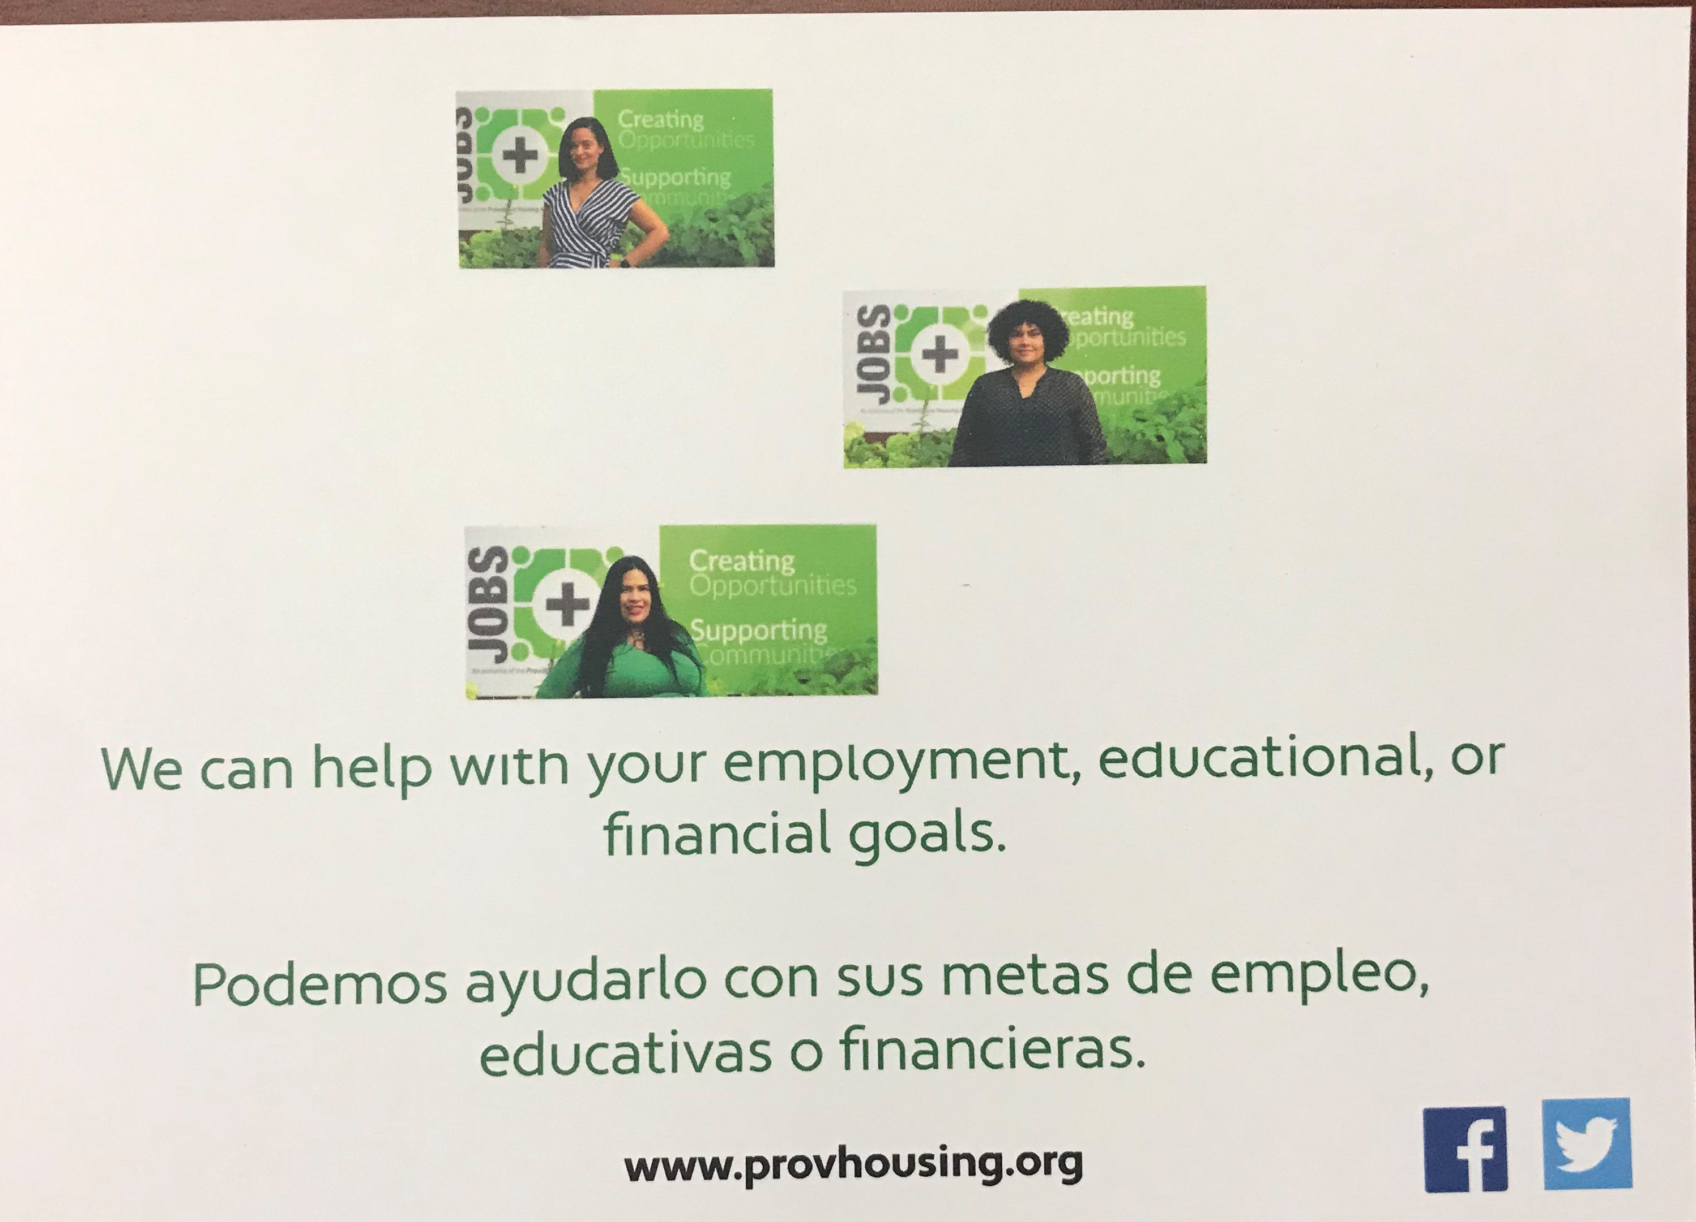
- Employment Case Managers have called everyone on their caseload informing them of the end of JPEID and that the supportive services will continue.
- Property Managers from MH and HP will continue to send referrals to the Financial Coach to assist JPEID recipients that have a significant increase in their rent due to the end of JPEID.
- A post card was created and will be sent out to all residents in MH and HP. A picture is attached.
- The JPP Manager sent out a partner email thanking them for their dedication to serving our residents and informing them of the end of the program.

Workforce Development Coordinator
- Conducted Outreach calls to JPP participants that are looking for employment.
- The Workforce Development Coordinator has established partnerships with the district recruiters of Amazon, Burger King, Santander Bank, and Admiral Packaging.
- Challenges with employers-Now with enhanced safety protocols employers are becoming more stringent on the language requirement.
- Assisting with WIOA outreach to 18-24-year-olds.
- The WDC attended the Providence Creative Council Meeting. This month they discussed what has been occurring with the city-specifically with COVID. The economic growth opportunities and improvement for creative tourism as tourism brings the majority of funding to the city and creates more jobs. The challenges of employment and business owners. The amount of closed business and how it has impacted the economic status of providence. As well as homelessness and drug abuse within providence due to depression and economic issues during and after COVID.

WIOA
- The WIOA contract was finalized and signed on September 3rd, 2020.
- Recruitment for the WIOA program started on August 17, 2020. The Employment Case Managers have connected with a total of 111 PHA youth between the ages of 14-24.
- The Resident Services Coordinators outreached to youth in Chad Brown and Manton Heights, Hartford Park, and Codding Court. They have connected with over 150 youth.
- A total of 19 young people has completed the WIOA application and are scheduled to be CASAS tested between September 23, 2020, and September 24, 2020. The Genesis Center will proctor the exam.

Financial Coach/Homeownership Program
- The Homeownership Seminar is scheduled for November 12, 2020, from 1:00-3:00 pm.
- Financial Workshops are scheduled for November 17 & 19- 1:00-3:00 pm.
- A pilot project in development to make strategic referrals to the Financial Coach for Residents with a repayment plan resulting from the COVID 19 impact. The FC has scheduled Zoom workshops, one-on-one meetings, reviewing their credit, and establishing a livable/manageable budget.

FSS
- There is a total of 138 participants
- In July and August 3 new contracts were signed.
- There have been 0 (zero) extension request due to COVID

- ADULT EDUCATION PROGRAMS:
- Genesis Center-conducting on-line distance learning for Adult Basic Education classes and phoneline conferences to work collaboratively on outreach and recruitment for programs.

- RESIDENT SERVICE COORDINATION:
- There is a total of 165 participants for Family Development RSC’s.
- Unemployment Application support
- Family RSC’s developed Standard Operating Procedures for Outreach and Service Delivery for Participants and Non-participants in the program
- Flu shot schedule – October and November; Family flu shots will be offered through Lifespan at the same time as Covid testing, and the High Rise flu shots will be offered at the same time as the food delivery.
- Lead RSC is leading the Food Delivery Program
- High Rise RSC is leading the Covid Hotline project

RSD Partnerships:
- Boys and Girls Club-The Boys and Girls Club are in the process of developing a plan to comply with State regulations
- Children’s Friend-Program start date TBD
- Family Service of Rhode Island Be Safe Plus program - a service providing deliveries of fresh foods and cleaning supplies to elderly and disabled residents. Boxes of fresh foods along with safety supplies like masks, hand sanitizer, toilet paper and more delivered to residents who register with The Point.

RSD Planning Updates:
  - Staff moving back on-site on Tuesday, September 8th
  - Re-vamping the MMR data collection from staff to streamline and more accurately reflect outcomes based on function (i.e.: Wellness programs, Workforce programs, Education programs, and Resident Service Coordination.)
  - Development of Dreams to Reality Youth program at Chad Brown
  - Reviewing and refining Year 1 Strategic Planning goals
  - Development of RFP for a grant writer for Resident Services
  - In development is a common Resident Services Department Key Performance Indicators (KPI’s). As Resident Services continues to coordinate goals as a department and identify performance and outcomes, referrals are the common indicator across programs. This table is in development, and a new way for staff to review and evaluate the impact of their work. In the table below, the “x” indicates that the staff is new to the Resident Services Department. The number of Residents following up on the referrals will indicate that a Resident’s personalized goals are in progress for a successful outcome

 | Family RSC’s | Highrise RSC’s | VOCA | SOR | CHW | ECM | Financial Coach | Workforce Developer | FSS | Social Worker | August  2020 | YTD TOTAL
staff | 2.5 | 2 | 1.5 | 1 | 1 | 2 | 1 | 1 | 2 | 1
Referrals to RSD from PM/Other Departments to | 21 | 3 | 2 | 2 | X | 0 | 0 | X | 3 | X | 31 | 31
Interdepartmental referrals made within RSD for services | 27 | 2 | 0 | 0 | X | 30 | 0 | X | 2 | X | 61 | 61
External referrals to outside agencies for services from | 69 | 8 | 2 | 2 | X | 40 | 0 | X | 26 | X | 147 | 147
Number of Residents following up on internal referrals
Number of Residents following up on external referrals

OFFICE OF STRATEGY AND DEVELOPMENT, COVID-19 REPORT
AUGUST-SEPTEMBER
High-level communications with partners, funders, and government – OSD is in communication with government partners at all levels.
Federal:
Participation in calls with HUD and reviewing HUD and other federal guidance. Participation in PHARI/Boston HUD Office update calls. HUD is updating its FAQs regularly and we are reviewing and sharing with the Executive Director and other departments as needed.
State:
We have been in ongoing communication with the Rhode Island Department of Health, who in May assigned a new point person to work with Housing Authorities, and are participating in biweekly calls with all members of the Public Housing Association of RI and RIDOH, along with other state officials. OSD staff also participate in a weekly “Community Partners” call that RIDOH has with nonprofit agencies throughout the state, with a substantial focus on addressing health disparities relating to COVID-19. Most recently we participated in a meeting with members of the Health Department’s housing action team focused on COVID-19 response.
Partners:
We continue to participate in calls with housing advocates from around the state that are convened by HomesRI, as well as other calls with property managers from around the state convened by HousingWorks, and including participation and information sharing from Rhode Island Housing.
We maintain PHA participation in the Central Providence and West End Health Equity Zone projects, with the ConnectRI / ConnectProv initiatives for digital equity and access to technology, and with the current Accessing Home AmeriCorps program cohort of host sites.
Funding and Resource Development- OSD is coordinating fundraising and grant writing efforts across the agency.
OSD has identified possible sources of funding to support the extension of the PHA’s Emergency Food Box program – we have submitted a proposal requesting $50,000 to the Rhode Island Foundation. We also submitted a request for $20,000 to the Amica Charitable Foundation.
We are in very preliminary conversations with Innovate/Commerce about funding through the ConnectRI/Connect Prov initiatives to expand internet connectivity to several developments including Manton Heights, Hartford Park, and Parenti Villa. More info will be available in the upcoming months.
Recent funding notifications and updates
BCBS - Our AmeriCorps member, Caroline, started and has jumped in with gusto. We have scheduled several webinars for fall technical assistance to landlords and will be offering some monetary incentives to lease in neighborhoods of opportunity and to new units. A webpage has been created we are mailing a postcard to all City landlords with the info.
New and pending applications:
VOCA – We are still awaiting a response from the state on our $159,802 request for a third year of VOCA funding, which would commence in March of 2021.
ROSS – OSD staff is leading grant writing activity for the 2020 Resident Opportunity and Supportive Services program. This grant would fund Resident Services Coordinator positions at the PHA’s family development for the next three federal fiscal years. As a first step in developing the application, OSD disseminated a community needs survey to all 1,580 residents residing in family developments; residents may participate by returning a paper survey or by taking the survey online. The grant due date is 11/19/20.
TEXTRON Charitable Trust – OSD submitted a grant application, in the amount of $24,000, to support a portion of an RSD Employment Case Manager position for the Youth Workplace Immersion Program, a component to the PHA’s WIOA youth employment initiative.
Rhode Island Department of Public Health Crush Covid Mini-grants Program - OSD successfully applied for and received two grants, in the amount of $5,000 each, to conduct Covid-19 awareness and prevention activities at Manton Heights and Hartford Park developments. The grants will fund an outreach campaign and materials for us to encourage the use of masks for children.
HAIG – OSD submitted an application to the Housing Authority Insurance Group, with support from Legal Counsel, IT and HR, to request $56,394 to pay for a vulnerability scan and penetration test, to ensure the security of the PHA’s computer and internet networks. The grant program is to fund projects that could reduce potential future insurance losses by HAIG member agencies.
FEMA – OSD submitted a Request for Public Assistance (RFA), the first step in seeking reimbursement from FEMA for Covid-19 related expenses. OSD gathered information from multiple departments and submitted an application to FEMA for expenses incurred prior to April 27, which is the first date that any CARES Act funding can be spent. FEMA expenses, if approved, can be reimbursed at a rate of 75% which the PHA covering the remaining 25% of the cost. PHA has requested reimbursement of costs for sanitizing supplies, warning banners, mailing to Section 8 landlords and participants and drop boxes, contracts with vendors for building sanitizing and security, and increased labor costs. PHA contracts call for PHA to pay an hourly rate that is 1.5 times the usual hourly rate when essential employees are called in to work during a declared state of emergency. Staff submitting additional documentation in response to FEMA’s request for information concerning, warning banners, mailing of Covid-19 information to Section 8, drop boxes, and increased labor costs. FEMA has notified PHA that it considers the cost of a Covid 19 mailing to Section 8 participants and landlords to be ineligible as it will only consider costs incurred for the public housing program. FEMA has also denied reimbursement for the costs of the warning banners and drop boxes, deeming them as non-emergency increased operating costs. PHA has an opportunity to file an appeal of these determinations and has been in contact with the City’s Emergency Management Department; the City has hired a consultant to assist in in navigating FEMA reimbursement issues and PHA may be allowed to avail itself of the City’s consult in developing appeals. We have not yet received a response on whether FEMA will reimburse the portion of pay in excess of normal hourly rate. FEMA is indicating that it may not reimburse unless increased costs were due to employees working in excess of the number of hours normally worked per week. If there is a denial, PHA anticipates filing an appeal. OSD staff is communicating with FEMA staff to provide additional information as the agency processes our request.
Program Collaboration with RSD
OSD supported the continuing development of the State Opioid Reduction Grant funded Wellness Resource Center and authored monthly reports to the funder, BHDDH. OSD requested a no-cost extension so that unexpended grant funds, due to Covid-19, can be used past September 30. As of September 18, we still do not have a definitive response from the state. OSD also supported the development of youth employment programming and participated in monthly calls with HUD concerning JPP.
Mass Messaging
We coordinated with several departments across the agency to send mass message calls and text messages through CallMax:
 | May 2020 | June 2020 | July 2020 | August 2020 | Sept 2020
Total number of “bulletin” messages sent | 4 messages that included both languages | 38* | 67* | 115*  Updated to reflect end-of-month numbers | 36*  to-date 9/18
* In part because messages were targeted floor by floor or sent twice in an English and Spanish version.
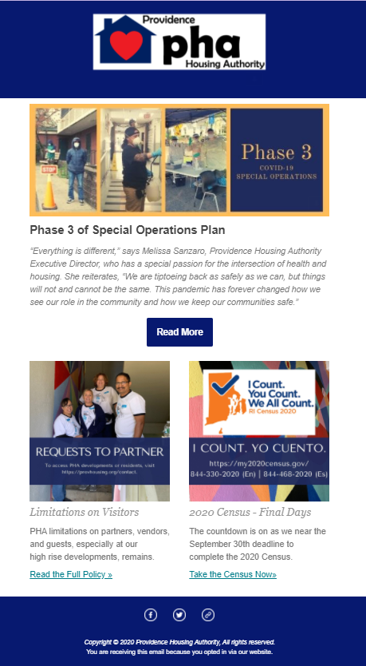
Messages include topics such as delivery of food and other essentials, testing, resident service program participation, partner program options and resources, and operational/policy related messaging.
Email blast to partners about our Phase 3 COVID Operations Plan
Lastly, we sent two landlord emails this month to ask opinions on incentives for our Blue Cross Blue Shield work and the second to share information about the Safe Harbor Program.
RAB communications and report
OSD staff members continued to do regular Zoom check in calls with RAB members to identify resident community concerns and needs and to provide information and updates. OSD continued a series of two RAB conference calls each month in the first week of the month and then a full RAB meeting on the third Wednesday of the month. OSD promptly advises Departments of any issues identified in RAB contact so that they can be addressed and authors a weekly report that summarizes issues; the report is disseminated to all PHA Departments. As of August 15, group calls have been scheduled to twice per month.
We have worked to address issues identified by RAB members on an ongoing basis, such as:
- Concerns about residents and visitors not taking mask wearing seriously.
- Concerns about residents in family developments not taking seriously social distancing requirements by hosting gatherings in excess of state limitation.
- Concerns about residents improperly disposing of trash and illegal dumping by outside persons at family developments.
- Residents struggling with mental health and addiction issues; and
- Parties drawing more persons than allowed by the State mandate.
Full RAB meetings via Zoom continued in August and September to gather the group. The August meeting provided presentations PHA’s Resident Services Department and Caption Call. Caption Call is an organization that provides not cost access to phones with screens that provides transcription of spoken words. After the monthly meeting, a RAB member had a Caption Call phone installed and reported it has completely changed her communication with her family and friends. The September meeting provided a presentation on trends in security by Security Director Daniel Murphy and a presentation by Property Management Director Michelle Rocchio concerning the PHA’s new online rent payment option and the PHA’s revised policy about fees for late payment of rent. The meeting also included a virtual presentation of certificates of appreciation to RAB members to recognize their outstanding commitment to PHA and their fellow residents by their participation in weekly calls and contact with PHA throughout the pandemic.
An OSD staff member served as a volunteer trainer for a 16-hour Alternatives to Violence Project or AVP training in which three RAB members are participated. AVP is an international program, founded in 1975, that seeks to build communication, diversity appreciation, and conflict resolution skills as means to prevent violence. The all-volunteer program has chapters in many states, and a chapter is being formed in Rhode Island. The training sessions, conducted during the evening, are being held remotely via Zoom and this is the first remote AVP training in the U.S. An Advanced AVP training session will be conducted in October. AVP hopes to train a core group of Providence residents who will be certified to serve as facilitators in future AVP training events. A Hartford Park RAB member and an OSD staff member will be participating as students in the training and another OSD staffer will serve as a member of the training team.
Strategic Planning
As we maintain our focus on COVID-19, we are also seeking to continue work to carry out the Strategic Plan. In May we finalized the strategic plan document content and design. We also summarized and presented the document to the Board of Commissioners at the May meeting for adoption. In May and June, OSD identified draft Year 1 strategies and actions, making certain to align actions departments must undertake during the COVID emergency with overall strategic plan goals. OSD continued to confer with all other departments to review Year 1 strategies and actions in light of new capacity considerations and new opportunities as a result of COVID-19 operations in August, with adoption and metrics expected to be in place by late September to cover the PHA’s 2021 fiscal year.
Repositioning
OSD staff gathered materials for and participated in a Repositioning Roundtable with HUD experts and several other housing authorities in the Boston Field Office area on August 4 . Experts participating in the Roundtable reviewed each PHA’s portfolio and made preliminary suggestions concerning possible repositioning considerations. OSD staff met Shannon Lestan, one of HUD’s repositioning consultants, on September 2 to begin the process of conducting a preliminary feasibility study concerning repositioning at PHA. OSD is in the process of gathering documents Ms. Lestan needs to assist us with this project.
2020 Census Outreach
OSD staff assisted Census Team members by staffing tables at all food distribution efforts in August. As we near the September 30th deadline, we are coordinating with the regional Census team to conduct final outreach to all those who had not yet been counted with a focus on our high-rise communities.

Sunset Village Beautification Project
OSD staff will work with the development’s RAB representative and a team of resident volunteers to plant flowing spring bulbs and prepare beds for winter in September.
Manton Heights
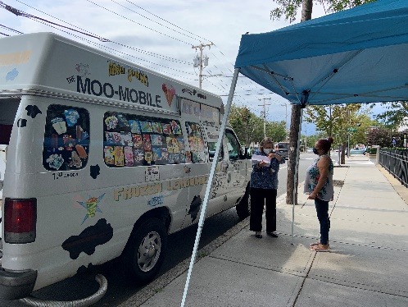
OSD staff will work with Manton Heights RAB member Lonzie Doggett to plant fall flowers and spring flowering bulbs in the area of 49 Salmon Street in September as a first step in re-engaging residents in an effort to re-establish an active Resident Association at the development.
Tropical Storm Isaias Response
OSD staff worked with PM staff and the Hartford Park Resident Association to assist residents impacted by Tropical Storm Isaias on August 4 to complete necessary documentation for SNAP benefits that replace food they lost when power was out over a two- day period.
Lemonade Truck Event at Carroll Tower
OSD coordinated with the RAB members at Carroll Tower on August 27 to have the Moo-Moo Mobile come and offer free lemonade and ice creams to the tenants. Residents were grateful to enjoy a break from the monotony caused by the pandemic.
Carroll Tower MooMobile event
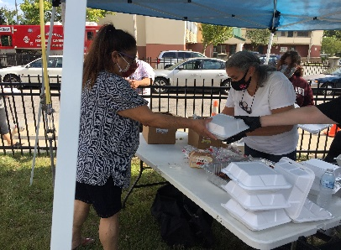
Cook-out Event at Hartford Park
Hartford Park Hot Dog Roast on August 28
Dinners containing two hotdogs and a bag of chips were served to Hartford Park and Tower residents on August 28.
This is the first cookout since the pandemic, and it was successfully implemented. Each meal was served in a covered container and given to residents with masks waiting in line marked for social distance.
OSD staff assisted the President of Tenant Association at Hartford Park with arrangement of tent, chairs, and other equipment for event. Staff was also present to make sure safety guidelines were followed.
PHA-CDBG Intake Forms
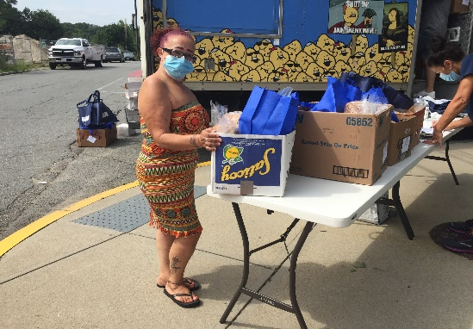
OSD staff was present at all high-rise developments, including Sunset Village, on the week of September 7th and 14th during food distribution. Staff requested residents to sign intake forms for PHA to continue receiving funding for food boxes.
Be Safe Plus boxes being delivered to PHA sites.
Be Safe Plus Box Distribution
OSD coordinated with Family Services of Rhode Island (FSRI) to distribute over 100 BeSafe Plus boxes of fresh produce and cleaning supplies to residents age 60 and over at Manton Heights, Chad Brown, Hartford Park, Dexter Manor and Codding Court for the months of August and September. Residents were appreciative of the boxes especially the fresh vegetables, fruits and eggs provided.

